Laptop Price Prediction using Machine Learning Algorithms

Dr . R. Kamalakar
Department of Computer Science &Artificial Intelligence
SR University
Warangal, Telangana State, India
niharali@gmail.com
Mahankali Koushik
Department of Computer Science & Engineering
SR University
Warangal, Telangana State, India
2003A53010@sru.edu.in
Arrabelli Jona Karthik
Department of Computer Science & Engineering
SR University
Warangal, Telangana State, India
2103A51L03@sru.edu.in

Abstract— The laptop has grown to be one of the most essential and used gadgets in our day-to-day existence for different activities. We will be supplied with many specs and company names in the market, it will become difficult for laptop computer makers to sell their merchandise and for customers to pick out one. Machine learning (ML) is high quality in assisting in making decisions and predictions from the large volume of facts produced. We have additionally viewed ML strategies being used in recent developments in the Internet of Things (IoT) areas. Various studies supply solely a glimpse into predicting the price of the laptop with ML techniques. In this paper, we suggest a novel technique that targets finding tremendous elements using making use of desktop getting to know fashions resulting in improving the accuracy in the prediction of laptop price. The prediction model is delivered with one-of-a-kind combos of features and several regarded computing device learning models. We are the use of a one-of-a-kind laptop to gain knowledge of fashions like Decision trees, Multiple linear regression, KNN, and Random forest to test which desktop mastering model is more accurate in predicting the rate of the laptop.
Keywords— Machine learning, Data Mining, prediction model, Classification, Multiple linear regression, Random Forest, Decision tree and KNN, Laptop price predictor

Introduction
The importance of laptops in our each day lives cannot be overstated. Humans evaluate and undertake science daily in everyday life. Laptops, like computer computers, are ubiquitous in our everyday lives. Raw statistics are changed into valuable and meaningful information in all of these areas: companies, banks and universities, and homes. Engineers, students, teachers, commercial enterprise people, and authorities businesses all use it for particular duties, amusement, web earnings, and office work. Laptops are a blessing for people if they are used for proper causes. The majority of companies maintain all of their operational and accounting statistics on a laptop. Today, a diploma in international enterprise operations except for the use of pc applied sciences and the web is unthinkable. Laptops make it simple to save and continue data, as well as come across archives and essential information. Excel sheets, documents and administrative systems, transaction processing, and traceability systems are just a few examples of equipment and software that make administrative work easier and greater productive. The company’s laptops can compute and summarise statistics entered in reports, statements, and papers that are utilized for a range of purposes. Databases are maintained on laptops by organizations of all sizes. Databases are pc programs that store and manipulate essential data, such as patron contact information.
Machine Learning is a department of Artificial intelligence that offers implementation purposes that can make future predictions based on past data. If you are a facts science enthusiast or a practitioner then this article will assist construct your own end-to-end desktop studying project from scratch. There are a variety of steps involved in building a laptop studying undertaking but not all the steps are obligatory to use in a single project, and it all depends on the data. In this article, we will construct a Laptop charge prediction challenge and examine the laptop by studying its mission lifecycle.
In machine learning, a multiple regression model is a type of supervised learning technique for estimating the mapping feature to reap excellent predictions. Regression's primary motive is to construct an efficient model that can predict the based attribute from a list of attribute variables.
To attain this purpose, we will perform the following steps:
- Building the model
- Training the model
- Make predictions
- Evaluate the model
For attaining this goal, we use specific steps:
- Problem Statement
- Data Set
- Pre-Processing; dividing data into train and test datasets; and Visualizing
- Performance/Evaluation
- Result
- Conclusion

LITERATURE REVIEW
Paper – [1]: In "Classification Based on Decision Tree Algorithm for Machine Learning" Behzad Tahaz Jijo1*, Adnan Mohsina Abdulazeez2 proposed the basic goal of the Decision tree algorithm, Decision tree algorithm, which belongs to the supervised getting to know algorithm family, is building a coaching model that can be used to predict the class or cost of goal variables by using inferring decision policies from coaching data. Regression and classification problems can each be solved with the use of the Decision Tree technique. The Decision Tree is ordinarily used for grouping purposes. Furthermore, the Decision Tree is a common categorization model in Data Mining. Each tree is made up of nodes and branches. Each subset defines a price that the node can take, and each node represents facets in a category to be categorized. Decision trees offer a wide variety of functions due to their easy analysis and precision across many statistics types.
Decision tree nodes are frequent for presenting a extra entire photo of overall performance results. All recognized statistics classifiers use optimized splitting parameters and are upgraded.
- Merits: No prior hypotheses are included in the evaluation of the results' quality.
- Demerits: The decision tree has a lot of layers, which makes it intriguing.
Paper–[2]: In "Decision tree methods: applications for classification and prediction" paper Ying Stanford University | SU Department of Data Science Ph.D. Yan-Yan Song's Shanghai Jiao Tong University proposed that
A frequent facts mining approach for constructing classification structures based totally on several covariates or creating prediction algorithms for a goal variable is the choice tree methodology. A population is divided into branch-like segments that shape an inverted tree with a root node, interior nodes, and leaf nodes. The algorithm is non-parametric, which capability it can take care of huge, complicated datasets besides imposing a complicated parametric framework. Study information can be separated into training and validation datasets as soon as the sample dimension is massive enough. Building a decision tree model with the coaching dataset and finding out the right tree dimension with the validation dataset to produce the nice last model. CART, C4.5, CHAID, and QUEST are some of the algorithms used to create decision trees.
One of the most essential and powerful algorithms in prediction is the Decision Tree. It's simple to anticipate the result for future data the usage of the tree model got from prior data.
Tools and techniques: Jupyter notebook, Decision Tree
Merits: Divides original input variables into meaningful subgroups, simplifying complex relationships between input variables and target variables.
Demerits: The key downside is that it is susceptible to overfitting and underfitting, especially when working with small statistics sets.
Paper – [3]: In the paper "Popular Decision Tree Algorithm of Data Mining Techniques" Radwan Abbas F. H. Alhaurin, Ali S. A. Al-Haboob were discussed the selection tree Depending on the quantity of data, the effectiveness of the method, and the amount of memory available, the Decision Tree classification algorithm can be performed in serial or parallel phases. A serial tree is a logical model that is constructed with the use of a coaching information set and is represented as a binary tree. Using predictor variables, aids in the prediction of the cost of a goal variable. As illustrated in Fig. 1, selection timber makes it simpler to signify data and generate IF-ELSE categorization rules.
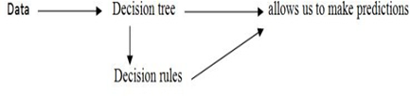
It is made up of hierarchically arranged rules. It's a simple recursive shape for presenting a judgment method in which a future instance is labeled into contemporary distinct classes and observations are divided into jointly different subgroups. Each department of the tree represents one or greater data from the original records collection. The root node (no inbound link) is at the pinnacle of the tree and represents all of the rows in the dataset. The internal or choice nodes (with solely one incoming link) are used to take a look at an attribute.
Tools and techniques: Jupyter notebook, Decision Tree.
- Merits: Decision trees do not require data normalization, and they are highly accurate prediction models.
- Demerits: Decision trees do not require data normalization, and they are highly accurate prediction models.
Paper – [4]: Random Forest is made up of various special tree shape nodes. There are many interesting things in Random Forest. Random Forest has seen vast utilization in categorization, prediction, and regression. Random Forest affords a lot of blessings over common algorithms. As a result, Random Forest has a vast variety of applications. Traditional machine studying techniques generally result in low classifier accuracy and are susceptible to overfitting. Many human beings study algorithms for merging classifiers to enhance accuracy. Many researchers start their research to improve classification accuracy by using combining classifiers. Leo Breiman advanced the Bagging algorithm in 1996, which is an early-stage algorithm [1]. Amit and German define a giant range of geometric points and search for the great cut-up at each node using a random selection of these features[2]. Dieterich proposed the random break up resolution theory[3] in 1998. The split is chosen at random amongst the N fantastic splits at each node. He has done a tremendous lookup on "the random subspace" approach, which develops each tree by selecting a random subset of characteristics at random. Breiman [5]creates new education units via randomizing the authentic coaching set's outputs. Among these, Breiman's questioning about random forests was once knowledgeable by using the idea in Amit and Geman's study. Random forests are a machine studying approach that combines various techniques. When these are paired with a sequence of tree classifiers, every tree casts a unit vote for the most famous class, and the outcomes are merged to get the closing sort results.
Tools and techniques: Jupyter notebook, Random Forest.
- Merits: Random Forest predictions are more accurate than traditional predictions.
- Demerits: The Random Forest can face up to noise higher thanks to the mixture of bagging and a random choice of aspects to split.
Paper – [5]: the University of California, Berkeley, CA 94720 published a paper Growing a group of trees and allow them to vote for the most famous type resulted in significant increases in classification accuracy. Random vectors that regulate the increase of every tree in the ensemble are frequently built to grow these ensembles. Bagging (Breiman, 1996) is an early example, in which a random choice (without replacement) is selected from the instances in the education set to develop each tree.
They outline a huge wide variety of geometric facets and search thru a random decision of them for the fantastic break up at every node in an important paper on written personality recognition. This remaining paper has affected my thinking. In all of these techniques, a random vector okay is created for the kth tree, unbiased of the previous random vectors 1,...,k1, however with the equal distribution; then a tree has shaped the usage of the coaching set and k, resulting in a classifier h(x, k), where x is an enter vector. For example, in bagging, the random vector is generated by counting the variety of darts thrown at random into N boxes, the place N is several examples in the training set. Several independent random integers between 1 and K are used in random split selection. Its dimensions and character are determined via its software in tree construction. They vote for the most popular category as soon as a huge variety of timber has been created. These strategies are regarded as random forests.
- Tools and techniques: Jupyter notebook, Random Forest.
- Merits: It's quicker than boosting or bagging.
- Demerits: A forest is more difficult to decipher than a single decision tree.
Paper – [6]: Celine Vans Department of Computer Science, Kotolike University Belgium said that A random forest area is a group of random Decision Tree nodes that combine the predictions of individual nodes to make predictions. Different methods for introducing randomization into the selection tree construction manner exist. A random forest can be used to forecast goal residences that are nominal (Classification) or numeric ( Regression). One of the most wonderful forecasting models is random forests.
- Tools and techniques: Jupyter notebook.
- Merits: They are rapid to construct, even when there are a massive number of attributes because only a small part of the attributes are examined at each node.
- Demerits: The knowledge acquired through random forests is extra tough to interpret than the expertise discovered by way of the decision trees that they employ as their basis classifiers.
Paper – [7]: "A Brief Review of Nearest Neighbor Algorithm for Learning and Classification"Khalid Alkhatib, and Hassan Najadat say that the KNN is a machine learning approach that is very easy to use. A similarity-based categorization can be used to map the prediction problem. A set of vectors is created from the historical and test data. Each feature is represented by an N-dimensional vector. Then, to make a choice, the same measure such as Euclidean distance is computed. A description of KNN is supplied in this section. KNN is a type of lazy learning in which no mannequin or feature is constructed previously and as a substitute returns the k information from the education information set that is the same as the test. The type label is then determined through a majority vote among the chosen ok records. The query file is then assigned to it.
The following is how the fee forecast has calculated the use of KNN:
a) Calculate the variety of closest neighbors (k).
b) Calculate the value of the distance between the training and question samples.
c) Filter all of the coaching data by using distance values.
Tools and techniques: Jupyter notebook, KNN Predictor.
d) For the classification labels of k nearest neighbors, uses a major part and predict it as the query record's prediction value.
- Merits: The time to calculate is quick.
- Demerits: The prediction step may be slow with large data.
Paper – [8]:, Suraj, and Surendra Babu K N proposed stock prediction the usage of the Knn algorithm is the k-nearest neighbor algorithm is a supervised algorithm that is easy to construct. KNN is also characterized as the laziest studying method, as it no longer strengthens a mannequin or functionality before returning the closest ok values from the training dataset to take a look at the data. The category label is then allotted to the take a look at statistics when a majority vote is received amongst the chosen okay values.
KNN is used to calculate the following tiers for predicting stock prices:
1. The quantity of okay values is set to 15 in this case.
2. After that, 70% of the education records and 30% of the testing facts would be taken.
3. The Euclidean distance between the education and checking out datasets will be calculated.
4. Filter all of the coaching samples by using their distance values.
5. Assign the KNN type label as an envisioned fee of the checking out records primarily based on a majority vote.
- Tools and techniques: Jupyter notebook, stock price predictor.
- Merits: Flexible – can be used for regression and classification.
- Demerits: High memory requirements — all training data must be stored.
Paper – [9]: Kashvi Trunk, Sanjukta De, Srishti Verma, and Aleena were said that When precise approximations of chance densities were unknown or difficult to estimate, K-nearest-neighbour classification was once created to operate characteristic analysis. Fix and Hodges devised a non-parametric method for pattern categorization in an unpublished US Air Force School of Aviation Medicine find out about in 1951, which has now ended up recognized as the KNN Rule.
- Tools and techniques: Jupyter notebook, Custom KNN Model.
- Merits: There is no training period: KNN is recognized as the Lazy Learner. During the coaching phase, it does no longer examine anything. The coaching information is not used to generate any discriminative functions. In different words, it does now not require any training. It saves the education dataset and uses it solely when making real-time predictions to examine it. This makes the KNN method plenty faster than other training-based algorithms like SVM and Linear Regression.
- Demerits: Feature scaling is required: Before applying the KNN technique to any dataset, feature scaling (Equalization and normalization) is required. If we don't, KNN may additionally make unsuitable predictions.
Paper – [10]: Naalla Vineeth and Maturi Ayyappa proposed MLR is an upgrade of simple linear regression that permits two or more predictor variables to model a response variable, y, as a linear function, whereas easy linear regression only has one. The most frequent kind of linear regression evaluation is more than one linear regression. Much linear regression is a predictive evaluation that indicates the hyperlink between a continuous established variable and more than one independent factor.
- Tools and techniques: Jupyter notebook, Regression Model.
- Merits: It's a simple technique to forecast profit.
- Demerits: When compared to other algorithms, it does not have a greater prediction capacity.

PROBLEM DEFINITION
The problem assertion is that if a consumer needs to buy a laptop, our utility ought to be able to deliver an estimated price for a laptop primarily based on the user's preferences.

DATASET
- For this project, we have obtained my dataset from Kaggle. This dataset contains 1302 rows of data and 12 columns (features) that we could focus on to build our prediction model i.e., we use 12 attributes to predict the price of the laptop.
- The dataset consists of 12 attributes
- Brand
- Type of laptop
- RAM
- Weight
- Touch screen: It has only two values i.e., yes(if it has a touch screen)or no(if it doesn’t have a touch screen).
Value 0:No
Value 1:Yes
- IPS: IPS [In-plane switching], is a one display panel technology. IPS panels are the best type of display in the world and have the best color among the other types of display panels. It has only two values i.e., yes(if it has an IPS display )or no(if it doesn’t have an IPS display).
Value 0:No
Value 1:Yes
- Screen size
- Resolution
- CPU
- SSD
- GPU

DATA PRE-PROCESSING
Data pre-processing is an important task for a project in cleansing the information and making it appropriate for a machine-learning model which also increases the accuracy rate and efficiency of a laptop model. In this particular section, we relabel & convert some categorical features into numeric values. This is crucial for training machine learning models since machine learning models accept numeric values. We have a total of 1302 rows and 12 columns(attributes) in the dataset We also do feature engineering of CPU.
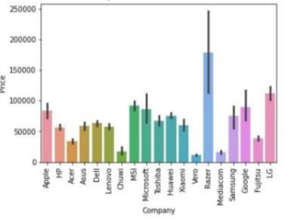
Figure 1. company attribute
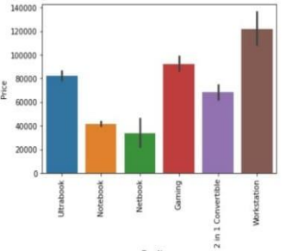
Figure 2. Type of Laptop

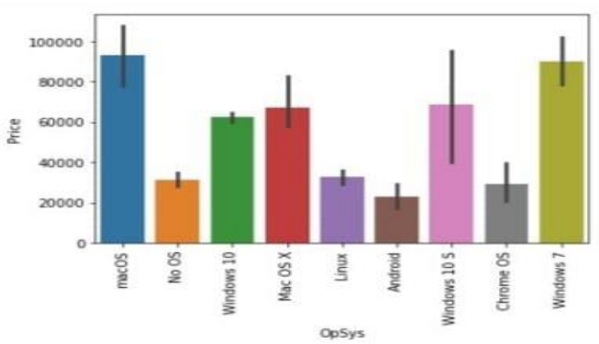
Figure 3 Operating System
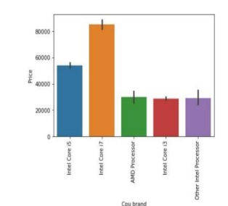
Figure 4 Processor
The above images were the output obtained after the pre-processing of the attributes of the dataset.

ALGORITHMS
We use a variety of Machine Learning models, all of which are different Regression models, to solve our Prediction problem and the top four are:
- Decision Tree
- Random Forest
- KNN Algorithm
- Multiple linear regression.
So, let's get our data ready for the training and testing of our machine learning model.
- Decision Tree: This algorithm is the phase of supervised gaining knowledge of the list of algorithms, and it is most important thing is to build a coaching mannequin that can be used for predicting the classification or fee of target variables via mastering user policies inferred from the coaching data. The Decision tree algorithm can be used to clear up regression and classification issues. Mainly for grouping purposes, the Decision Tree is used. Moreover, the Decision Tree is a usually utilized classification model in Data Mining. The nodes and branches are composed of every tree. Each node says that elements in a class are to be classified and every subset defines a price that can be taken via the node. Because of their easy evaluation and their precision on a couple of information forms, selection bushes have determined many implementation fields. Decision tree nodes are acknowledged for the superior view of performance outcomes. Because of their sturdy precision, optimizing split parameters, and greater tree pruning strategies like( ID3, and C4.5) are normally used through all identified information classifiers. The separate datasets are used in the training samples from large datasets, which influences the precision of the test set.
- Random Forest: Random Forest is a Group of Decision trees that utilizes a “Laptops database” for performing an import of an initially trained version of the proposed network used for implementing training over thousands of Laptops data, as a result, will build up a library of enhanced features that denotes accuracy of 87% and r2 score is 0.15% which are best compared to other algorithms.
- KNN: The prediction of the charge is computed by the usage of KNN as follows:
a) obtain the range of nearer neighbours, k.
b) Calculate the distance between the neighbours and the question record.
c) Filter all coaching archives by the values of distance.
d) Using the majority of the category labels of k nearest neighbours, and assigning it as an estimation price of the question record.

BUILDING THE MODEL
In this specific section, we relabel & convert some specific elements into numeric values. This is vital for education desktop mastering models when you consider that laptop studying fashions receive numeric values. We have a total of 1302 rows and 12 columns(attributes) in the dataset We additionally do characteristic engineering of CPU.So right here rather than display resolution, PPI (pixels per inch)has been taken. We cut upscreen decisions into x-resolution and y-resolution. From x-resolution and y-resolution we bought PPI(pixels per inch). After that screen decision is dropped and whilst splitting screen resolution we will get two columns for x-resolution and y-resolution. We will drop these two columns as well. Instead, we will have PPI(pixels per inch).
Looking at the dataset, we can see that some columns such as display screen resolution and Cpu have alphanumeric records whilst different aspects consist of in basic terms numerical or alphabetical values. These facts would need to be filtered and engineered
To avoid any problems and error-prone predictions, useless elements such as “Unamed:0”, “Company” and “Product” will be removed from the dataset.
We would now extract and reorganize our statistics to better recognize the underlying factors that contribute to the fee of laptops.

If we take a appear at the display screen decision column, there appear to be laptops with touchscreen capabilities. Since touchscreen laptops are regarded to be greater high-priced than those beside them, a TouchScreen characteristic would be introduced to mark laptops with such capabilities.
We would then extract and substitute the display decision column with their respective pixel count.
Now comes the most tiring part of characteristic engineering, dealing with memory features. Upon nearer inspection, the memory column incorporates several kinds of reminiscence (SSD, HDD, SSHD, and Flash Storage). We would need to create 4 extra columns representing special memory sorts and extract their memory capacities individually. (Additional processing desires to be achieved for laptops having double memory configuration that makes use of the equal reminiscence types.( EX: 256GB SSD + 512GB SSD).
Having those memory configurations handled, we’ve decided to drop the GPU column completely as it includes a high variability of GPUs. Intel GPUs are built-in GPUs, and Nvidia GPUs are discrete whilst AMD GPUs are both integrated or discrete.

COMPARATIVE STUDY
We have collected the accuracies of the existing publications
- Algorithms And Accuracy
Sl.No. | Reference | Algorithm | Accuracy in percentage
1 | [1] | Decision tree | 83.67
2 | [1] | Random forest | 88.25
3 | [2] | KNN | 79.93
4 | [2] | MLR | 79.52
5 | [3] | SVM | 80.83
6 | [3] | Extra Trees | 87.5
7 | [4] | AdaBoost | 79.29
8 | [5] | RidgeRegression | 81.2
9 | {6] | Lasso Regression | 80.7
10 | [7] | XG BOOST | 88.1
11 | [8] | Stacking | 88.1

PREDICTIONS
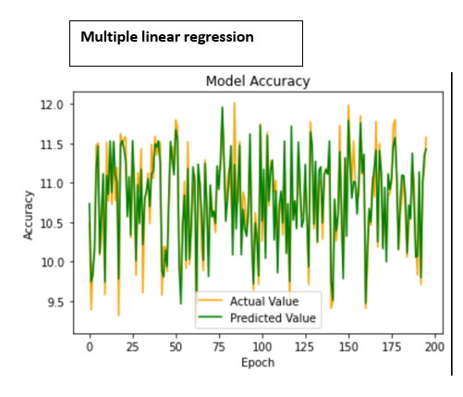
Figure 5: Multiple linear regression Accuracy
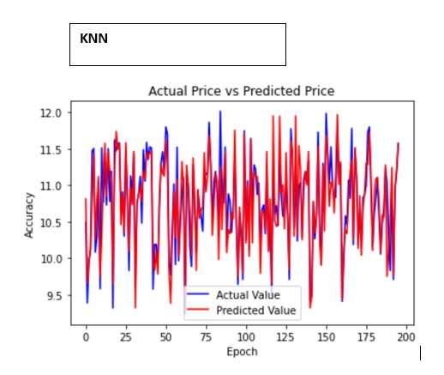
Figure 6: KNN Algorithm Accuracy
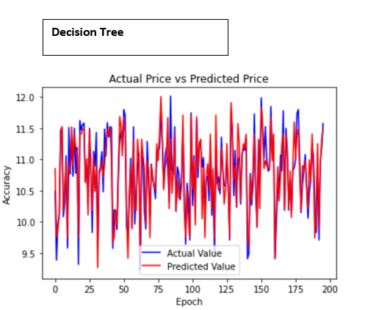
Figure 7: Decision Tree Accuracy
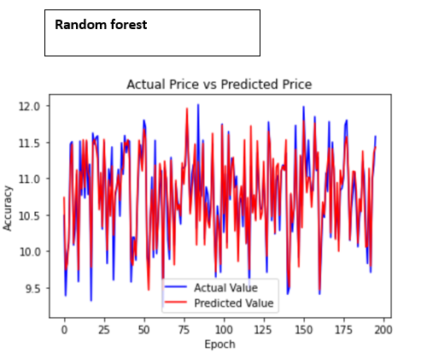
Figures. 8: Random forest Accuracy
The above figures represent the “Epoch vs Accuracy graph” which refers to the Model Accuracy of all the four different models that were implemented. We predict from test data; the following were the predictions made from four different models that were implemented.
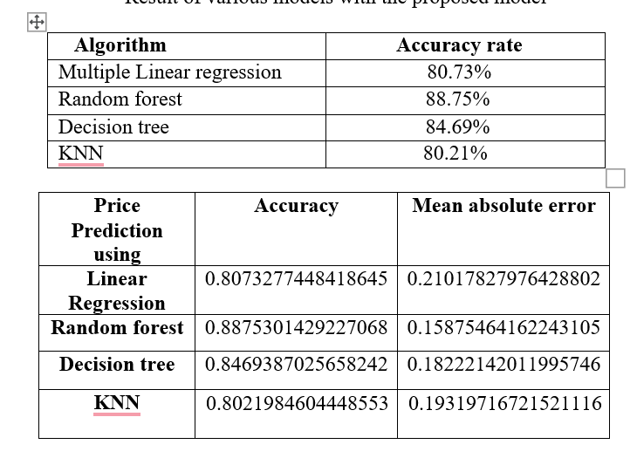
Figure 9:Accuracy and Mean absolute error rates
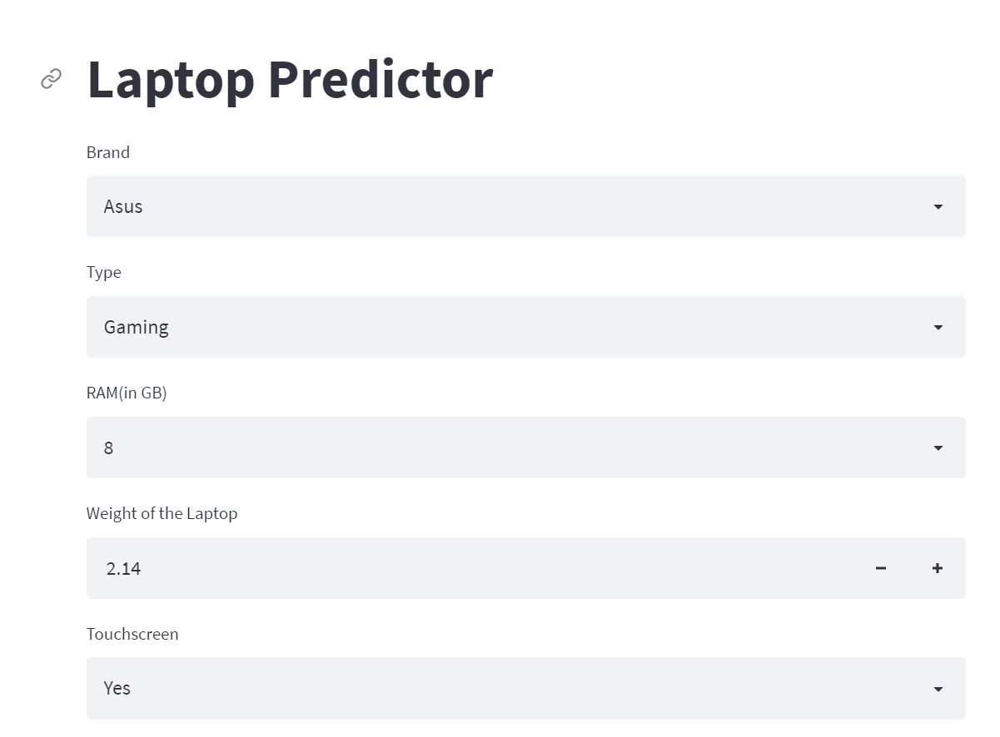

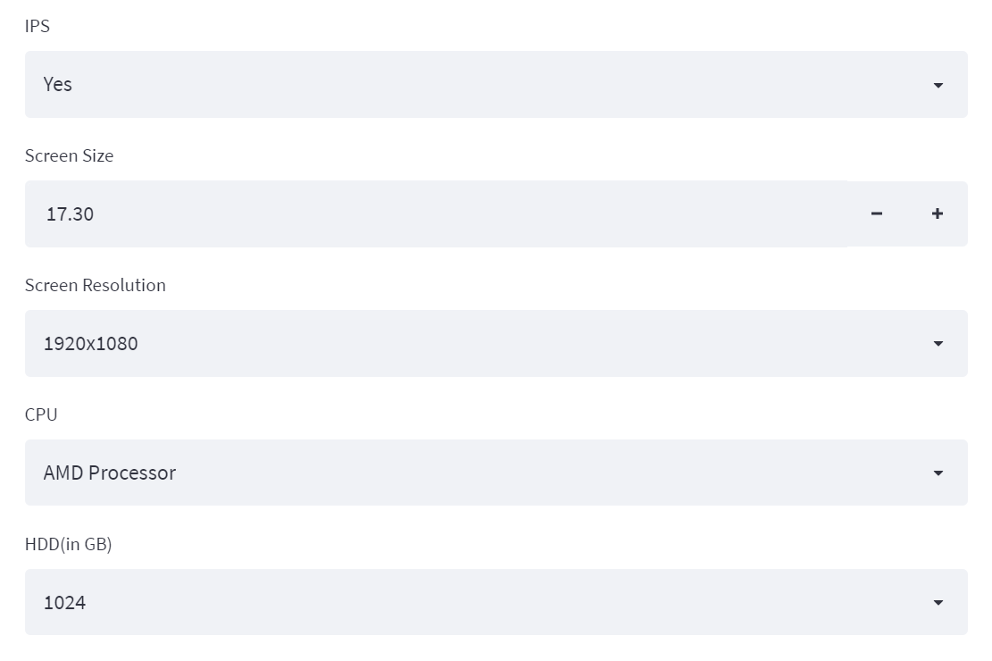

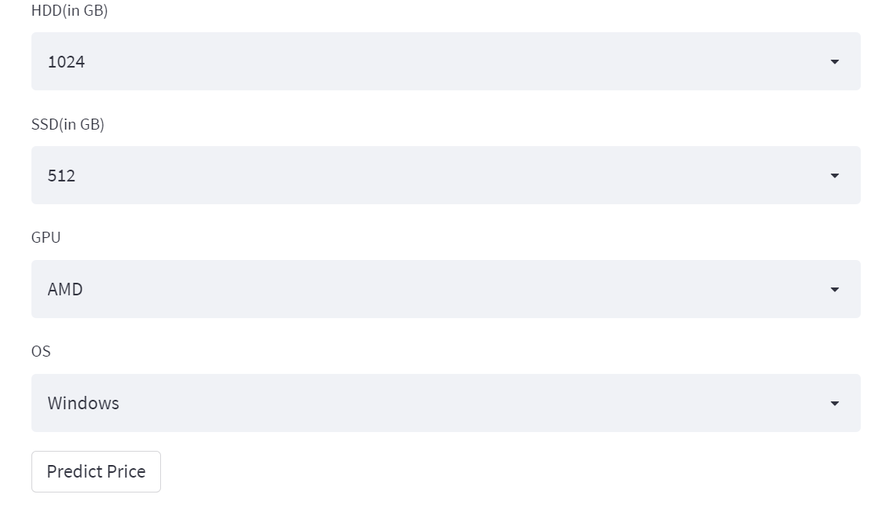

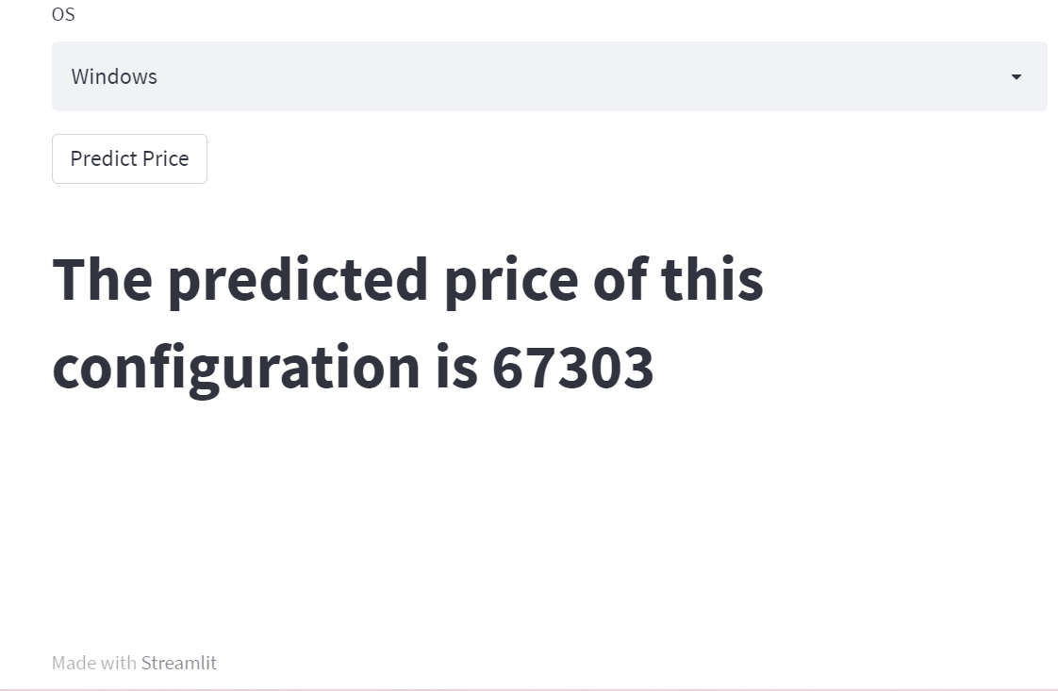

The above figures represent the results obtained through the Laptop price predictor site The algorithms that we used linear regression, random forest, and decision tree, KNN. As we can see from the above table, we compared the accuracy rates of four different models. When we compared above these algorithms the accuracy rate for the Random forest is more than the other two algorithms. The above table shows the accuracy rates of the algorithms and also the mean absolute errors of the algorithms, whereas random forest is 88.65%, linear regression is 80.65%, KNN is 80.45% and the decision tree is 84.05%.

CONCLUSION
We created a website that Predicts the prices of laptops using the user’s desired configurations and using laptop price predictors and gaining knowledge of using the Decision Tree algorithm makes it easy for students, in particular in deciding the choice of laptop computer specifications that are most ideal for students to meet pupil desires and by the buying energy of students. Students no longer want to appear for various sources to discover laptop specs that are needed by college students in assembly the wishes of students because the laptop computer specifications from the results of the computer gaining knowledge of application have furnished the most perfect specs with the prices of their laptops.

References
[1]. Aminah Md Yusof and Syuhaida Ismail, Multiple Regressions in Analyzing House Price Variations. IBIMA Publishing Communications of the IBIMA Vol. 2012 (2012), Article ID 383101, 9 pages DOI: 10.5171/2012.383101.
[2]. Babyak, M. A. What you see may not be what you get: A brief, nontechnical introduction to overfitting regression-type models. Psychosomatic Medicine, 66(3), 411-421.
[3]. Atharva shoogles, Priyanka chair, Akshata gaud, Jinal Jain.House Price Forecasting using Data Mining Techniques International
Journal of Advanced Research in Computer and Communication Engineering ISO 3297:2007 Certified Vol. 6, Issue 12, December
2017
[4]. Darshan Sanghani, Kelby Erickson, and Mohammad Al Hasan Predicting Zillow Estimation Error Using Linear Regression and
Gradient Boosting, IEEE 14th International Conference on MobilAd Hoc and Sensor Systems (MASS), Page(s):530 - 534.
[5]. Model, Azmi Bin Khamis, Nur Khalidah Khalilah Binti Kamarudin, Comparative Study On Estimate House Price Using Statistical
And Neural Network, International journal of scientific and technology, research volume 3, ISSUE 12, December
2014,Page(s):126-131.
[6]. Adyan Nur Alfiyatin, Hilman Taufiq, Ruth Ema Febrita, Wayan Firdaus Mahmudy,Modeling House Price Prediction using
Regression Analysis and Particle Swarm Optimization Case Study: Malang, East Java, Indonesia. (ITASCA) International Journal of
Advanced Computer Science and Applications, Vol. 8, No. 10,
2017, Page(s):323-326..
[7] S. Jyothirmayee, V. D. Kumar, C. S. Rao, and R. S. Shankar,
“Predicting Stock Exchange using Supervised Learning Algorithms,”
no. 1, pp. 4081-4090, DOI: 10.35940/invitee.A4144.119119.
[8] H. Snyder, “Literature review as a research methodology: An overview
and guidelines,” J. Bus. Res., vol. 104, no. 2019, pp. 333-339, DOI:
10.1016/j.jbusres.2019.07.039.
[9] N. S. Selamat, “An Overview of Big Data Usage in Disaster
Management,” vol. 11, no. 1, pp. 35-40.
[10] R. P. Schumaker and H. Chen, “Textual Analysis of Stock Market
Prediction Using Breaking Financial News: The AZFinText System,”
no. 2006, pp. 1 -29.
[11] H. L. Siew, “Regression Techniques for the Prediction of Stock Price
Trend,” DOI: 10.1109/ICSSBE.2012.6396535.
[12] M. K. A. Shatnawi, “ Stock Price Prediction Using K -Nearest Neighbor
( k NN ) Algorithm,” vol. 3, no. 3, pp. 32-44, 2009.
[13] C. Hargreaves, “Prediction of Stock Performance Using Analytical
Techniques,” vol. 5, no. 2, pp. 136-142, DOI: 10.4304/jetwi.5.2.136-
142.
[14] Magaji, A.S,” An intense Nigerian stock exchange market prediction
using logistic with back-propagation ANN model”, Science World
Journal, 9(2), pp.8-13, 2014.
[15] Shashank, D. S., V. Sruthi, M. L. Vijayalakshimi, and Jacob Shimona
Garcia. "Turnover prediction of shares using data mining techniques: a
case study." arXiv preprint arXiv:1508.00088,2015.
[16] Khan, W., M. A. Ghazanfar, M. Asam, A. Iqbal, S. Ahmad, and Javed
Ali Khan. "PREDICTING TREND IN STOCK MARKET
EXCHANGE USING MACHINE LEARNING CLASSIFIERS."
Science International 28, no. 2,2016.
[17] Zaidi, M., and A. Amirat. "Forecasting stock market trends by logistic
regression and neural networks: Evidence from KSA stock market."
Int. J. Econ. Commer. Manag 4, vol. IV, no. 6, pp. 220-234, 2016
[18] A. Nayak, M. M. M. Pai, and R. M. Pai, “Prediction Models for Indian
Stock Market,” Procedia - Procedia Comput. Sci., vol. 89, pp. 441-449,
1877, DOI: 10.1016/j.procs.2016.06.096.
[19] H. Karchalkar, A. Jain, A. Singh, and V. Kumar, “Open Price
Prediction of Stock Market using Regression Analysis,” vol. 6, no. 5,
pp. 418-421, 2007, DOI: 10.17148/IJARCCE.2017.6578.
[20] Y. Yaslan, “ Stock daily return prediction using expanded features and
feature selection,” no. 2017, pp. 4829-4840, DOI: 10.3906/elk-1704-
256.
[21]Mohammed Ali Shaik and Dhanraj Verma, (2020), “Enhanced ANN training model to smooth and time series forecast”, 2020 IOP Conf. Ser.: Mater. Sci. Eng. 981022038.

